Which Law Really Matters?
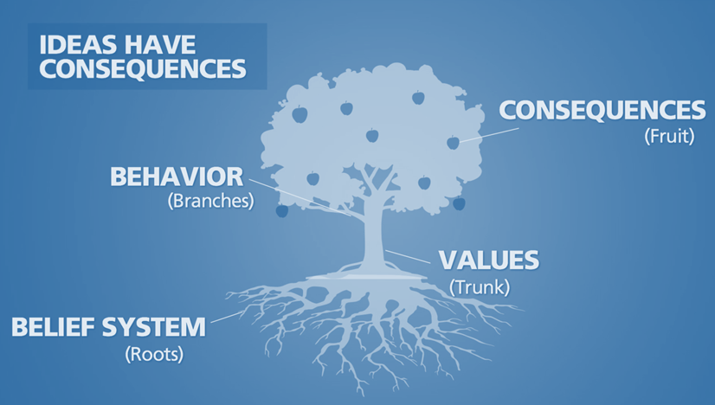

The NFL owners approved a new policy last Wednesday that was meant to stem the tide of negative reactions on the part of Sunday entertainment consumers toward players who were choosing to take a knee (or some such similar protest expression) during the playing of the national anthem. The players may now choose to remain in the locker room during the anthem, but once they are in front of the cameras and the crowds, such expressions will result in fines – not fines to specific players but to the teams.
Perhaps they are acting prematurely. While the reason for the protest seen on national television has been confused at best, organized protesters such as “Black Lives Matter” and their supporters want to claim that such expressions are drawing the public’s attention to the number of black people unjustly attacked or killed by law enforcement agents. Yet, the headlines for such things have greatly diminished even in the incendiary environment of Baltimore.
But when Officer Amy Caprio, a 4 year veteran of the Baltimore County Police, and a white woman, is run over and murdered in Perry Hall by a black 16-year-old, driving a stolen Jeep, who is described by authorities as a “one-man crime wave”, where is the public outrage? I am upset but is anyone else? not so much. I would like the Ravens to have the opportunity to all take a knee before the season opener to say that “white lives matter too”. They would do that, wouldn’t they? Now, they can’t. Rules are rules.
In the meantime, the governor of Texas is going through the necessary motions of reacting publicly to the Santa Fe shooting of 10 people by a 17-year-old who had stolen his father’s guns. Thankfully, the shooter was stopped by armed resistance on campus, although they have yet to be held up by the media as the heroes they are. Instead, the governor is considering a bill which would greatly restrict and supervise the way firearms are to be securely kept in private homes. Something that should be done will then “must” be done. How might that retard a homeowner’s reaction to own his house being broken into by other “one-man-crimewave”? “Wait a minute, I have to unlock my government-required and regulated gunsafe!”
It is hard to fathom how people can realistically feel that more laws on the books will actually bring about the behavior they want – especially from the generation that championed the phrase “laws are meant to be broken”. The laws that already exist are being broken. More laws levied on law-abiding citizens to restrict their private property and actions will persecute and restrict the wrong people. Perhaps even the resistance in Santa Fe might have been retarded under the current bill’s regulatory restrictions which might have yielded even more deaths.
But it is a very popular thing to “go after guns!”. “Yes! That would solve the problem!” But what about Officer Amy? She was the one with the gun. (I guess I should be very happy she didn’t hit any of those poor little boys in the car!) Well, should we also pass more laws about stealing cars? Raise the driving age to 18? Go after the manufacturers of Jeeps? (Remember, Jeeps were originally a creation of the government as a ‘weapon of war’.) You can easily hear what the immediate response to those things would be: “Oh, that would be ridiculous. That wouldn’t solve the problem!”
Legal laws will never be able to control the conscience. It is a clear sign of the degradation of our society that there has to be an increase of laws in our legal system because basic respect and morality are no longer regarded, modeled, taught or expected in our own homes. When the very notion of basic morality is raised, the libertarian protest is virulent. The principles laid out in God’s Moral Law are constantly under attack and rejected in the name of personal freedoms and selfish choices – even within the church! And because of that, the very thing that has and would bring a restraining change in our society is rejected outright.

Pastor David G Barker

