Studies in the Book of Daniel
Two Worldviews in the Age of the Fourth Rome
Be Aware of the Real Battle
Daniel 1:1-7

The book of Daniel reminds us:
a) that we are not living in Judah but in Babylon.
b) that we don’t have to worry about being like the world.
c) that materialism and hedonism are our friends.
What will bring substantive change to our country?
1)

2)

3)

What is the basic setting/context of Daniel’s story?
Daniel lived at the __________ of the divided monarchy.

Daniel was taken in order to __________________ Babylonia.

All of Daniel’s education of Yahweh occurred
(before/after) he was taken to Babylon.

What makes this book so vital for us today?
#1

With mankind, there is ___________________ new
under the sun.
#2

Christian ____________________ is absolutely vital.
#3

Our Christian _____________ must be active in our lives.

New Covenant Presbyterian Church, PCA, Abingdon, MD (410) 569-0289
A Traditional/Approximate Chronology
of the Old Testament

Age of the Patriarchs (Genesis) 2166 - 1805 BC
Egyptian hosting of Israel (Genesis) 1876 - 1446 BC
enslavement of Israel (Exodus) 1730 - 1580 BC
Wilderness Wandering (Exodus-Numbers) 1730 - 1580 BC
Conquest of Canaan (Joshua)
& the period of the Judges 1406 - 1050 BC
United Kingdom under David & Solomon
(1 & 2 Samuel, 1 Kings 1-11) 1050 - 931 BC
Divided Kingdoms
Israel (1 Kings 12-2 Kings 17) 931 - 722 BC
Judah (1 Kings 12-2 Kings 25) 931 - 586 BC

Exile in Babylon (Daniel) 605 - 537 BC

Return from Exile 537 - 444 BC
Period between Testaments 444 BC – 3 AD

Studies in the Book of Daniel
Two Worldviews in the Age of the Fourth Rome
How to Destroy a Church
Daniel 1:1-4
(see also: Dt. 6:4-9; 2 Kgs. 22)
Judah’s decline came from:
a) rejecting the teaching of Scripture.
b) forksaking the education of their children.
c) allowing for corruption in politics.
d) all of the above.
How to destroy the church:
I. Abandon the Moral Law of God
Josiah’s reform began with:

Dispensationalism led Christians to _____________ the law
of God in favor of grace.

Without the Moral Law man becomes just another
___________________.

II. Manipulate the education of children.
God’s covenant required God’s people to:

Decline begins
with neglect for _______________/_________________.

by replacing vision with __________________ -

ignoring the __________ and focusing on the ________.

III. Allow for the corruption in politics.
Friedrich Nietzsche coined the phrase “will to power”
to mean:

What can Christians do?

What hope do Christians have?

New Covenant Presbyterian Church, PCA, Abingdon, MD (410) 569-0289
Studies in the Book of Daniel
Two Worldviews in the Age of the Fourth Rome
How to Build a Covenant Community
Daniel 1:1-8
(see also: )
Daniel lived in the day
a) when Judah’s culture was clearly “post-Mosaic”.
b) when all was well in the world.
c) when the government took care of all our needs.
So where did Daniel’s godly character come from?
I. Young people need a faithful _________________.

As much as structure and discipline are needed in the home,
the presence of the _______________ of the gospel
is needed more.

The home needs Christian ______________________,

and Christian ________________ - ________________.

II. Young people need a faithful _________________.
What are the real priorities in choosing a church?
H__________________

Developing a _______________ - _________________.

III. Young people need a faith-based ______________________.
One that is ________________________.

One that is a ________________________.

One that is ___________________________.

New Covenant Presbyterian Church, PCA, Abingdon, MD (410) 569-0289
Studies in the Book of Daniel
Two Worldviews in the Age of the Fourth Rome
Compromise and Betrayal
Daniel 1:1-4
(see also: Prov. 3:11; Gal. 6:9; 2 Thess. 3:13; Heb. 12:3, 5; Rev. 2:3)
The Christian life is difficult because:
a) we have to be so perfect all the time.
b) other Christians are watching!
c) the challenges continue to rage in the heart.
I. Who are we?
In what ways is man an exceptional creature?

Do these gifts mean man’s motivation is always good?

What are the basic, biblical principles about man?
#1

#2

#3

#4

II. What does it take to live a Christian life?
A. The ground beneath us is always:

B. That means living as a Christian will always take:

C. But the gravitational pull on us means:
1.

2.

3.

All which can lead to
the __________________ of ____________________.
What happens when that affects the church?

When we feel resigned to defeat, need to remember:

New Covenant Presbyterian Church, PCA, Abingdon, MD (410) 569-0289
Studies in the Book of Daniel
Two Worldviews in the Age of the Fourth Rome
When the World Invades
Daniel 1:1-4
(see also: 2 Kings 24; Ps. 137; City of God)
Augustine lived during a time when:
a) aw, who cares?
b) when the people in the Roman empire had it great.
c) when the Roman empire was falling.
Daniel and Augustine wrote
of two __________________-_______________,
which means:

I. Daniel saw the world invade by invitation.
The historic formula for this:
1) a plea for _____________________.
2) a demand for _____________________.
3) an enforced ___________________________.
How would Daniel have seen this in his country?

II. Then, Daniel saw the world invade by force.
The lesson of the plagues of Egypt:
Plagues #1-3 –

Plagues #4-9 –

Plague #10 –

How did the people of Judah react to Babylon’s invasion?
Some simply ____________________ what they had lost.

Others asked:

Which must I be prepared to be?

New Covenant Presbyterian Church, PCA, Abingdon, MD (410) 569-0289
Studies in the Book of Daniel
Two Worldviews in the Age of the Fourth Rome
What’s In a Name?
Daniel 1:2-8
(see also: 2 Kg.s 20:16-18; Is. 39:6-7)
Hitler’s Third Reich
a) was the next progressive stage of Western Civilization.
b) was essentially a Christian empire.
c) rejected Western Civilization entirely.
I. The story of Daniel begins
A. by moving from voluntary compromise to temptation …

B. to involuntary coercion.
#1 – the eradication of ____________ and
________________.

#2 – personal ___________________________.

#3 – a required ___________________________________.

II. The change in the names
A. What was the purpose of the name change?

B. What did it really result in?

III. Names and Labels

What name/label do I want the world to know me by?

Daniel (“My judge is God”) => Belteshazzar (“May Bel protect his life.”)
Hananiah (“Yahweh is gracious”) => Shadrach (“The command of Aku”)
Mishael (“Who is what God is?”) => Meshach (“Who is what Aku is?”)
Azariah (“Yahweh has helped”) => Abednego (“Servant of Nebo”)
New Covenant Presbyterian Church, PCA, Abingdon, MD (410) 569-0289
Studies in the Book of Daniel
Two Worldviews in the Age of the Fourth Rome
Where Do Strong Christians Come From?
Daniel 1:5-16
(see also: Dan. 10:3; Lk. 18:9-14; 1 Cor. 10:23-33)
Where do strong Christians come from?
a) “Well, don’t look at me!”
b) “Strong Christian warehouses?”
c) “I know. I know. Here.”
Daniel is introduced to us here as a strong believer.
I. Daniel opposes the King’s diet.
Is this due to Mosaic dietary laws?

Why would the king give this to exiled teens?

Daniel asks ____________________.

Daniel _________________ his request carefully.

Daniel _________________ by asking this request.

II. How do we live out holiness in our own Babylon?
Holiness is not achieved by ________________________
but by ________________.

Holiness is not achieved by ________________________
but by ________________.

Holiness is not achieved by ________________________
but by ________________.

How do I become a stronger Christian?

“Some Christians are heroes in their daydreams only.” S. Ferguson
New Covenant Presbyterian Church, PCA, Abingdon, MD (410) 569-0289
Studies in the Book of Daniel
Two Worldviews in the Age of the Fourth Rome
Survival Tactics
Daniel 1:15-21
(see also: Gen. 19; 1 Kg.s 8; Job 1:21; 23:10; Is. 43:1-3; Gal. 3:15-18; Slouching Toward Gomorrah, R. Bork, “The Second Coming”, Yeats)
Daniel’s friends in Babylon were:
a) Shadrach, Meshach, and Abednego.
b) Tom, Dick, and Harry.
c) Hananiah, Mishael, and Azariah.
d) Larry, Moe, and Curly.

What are the Christian’s survival tactics?
I. ____________ and ___________________.
What Daniel did not do:

What Daniel did:

II. Believe in God’s ________________ _______________.
Our struggles have a bigger context –

Could our struggles have a purpose?

III. Trust God for his ______________ _____________________.
Is reality just what I see in the world?

Can God really use me to advance his purpose?

New Covenant Presbyterian Church, PCA, Abingdon, MD (410) 569-0289
Studies in the Book of Daniel
Two Worldviews in the Age of the Fourth Rome
Babylon in Space and Time
Daniel 1:17-21
(see also: Gen. 9:22; 10:11; Rev. 16:19)
Daniel and friends chose to deny themselves
a) and really missed out on some great stuff!
b) proved that a vegetable diet really is superior.
c) and were rewarded by God before the unbelievers.
I. What should I know about Babylon?
Nimrod –

“Going east” –

“fake stuff” –

II. Babylon in the days of Daniel
“Golden Age” –

Indoctrination –

What has Daniel become?
#1 –

#2 –

#3 –

III. What difference is the symbol of Babylon to us?
Our biggest sin –

“God __________________ ____________________.”

God also __________________ his ________________.

Which kingdom do I live in?

New Covenant Presbyterian Church, PCA, Abingdon, MD (410) 569-0289
Studies in the Book of Daniel
Two Worldviews in the Age of the Fourth Rome
When Science and Technology Fail Us
Daniel 2:1-12
(see also: Gen. 41; Num. 12:6-8; Dt. 29:29; Esther 6; Jn. 11:50)
People dream today
a) more than people used to do.
b) in ways that are rarely meaningful.
c) … sometimes during sermons.
Part 1: the dream of Nebuchadnezzar

Remember: it is not the sign that is most important, but the __________________ will of God.

Does Nebuchadnezzar trust his wise men?

How do the wise men respond to Nebuchadnezzar?
#1

#2

#3

The first prophecy in the book of Daniel is:

Who fulfills this prophecy?

New Covenant Presbyterian Church, PCA, Abingdon, MD (410) 569-0289
Studies in the Book of Daniel
Two Worldviews in the Age of the Fourth Rome
The God Who is There
Daniel 2:12-23
(see also: Dan. 1:17; Mt. 26:36-46; Jn. 17;)
Understanding how little control we have in life
a) is a constant disappointment.
b) is just a matter of our stubborn pride.
c) should keep us awake all night.
I. How did Daniel conduct himself?
Daniel’s reputation:

(True/False): Acting the way others around us do is always
a good idea.
I don’t want to just “go along to get along”,
but rather “go along to _________ ______.

Daniel makes the most of:
What is “prudence”?

Is that good or bad?

(True/False): When I want to be heard, I should
yell louder.

II. What did Daniel do next?
A. He went to his ______________ ________________.
(True/False): When I face a crisis, it is better
not to tell anyone.

B. They ____________________.
Will we always understand God’s plan for our lives?

How should we understand the figure of Daniel?

as a picture of myself?

as a foreshadowing of Christ?

New Covenant Presbyterian Church, PCA, Abingdon, MD (410) 569-0289
Studies in the Book of Daniel
“There is a God in Heaven”
Daniel 2:19-23
(see also: Ps. 115:4-8; Is. 40:3; Mt. 1:20; 2:13, 19-20; 11:11; Jn. 3:30;
Heb. 1:1-2; Jude 3; Rev. 1; 22:18-19)
Daniel had been given more time by the king because
a) the king forgot he had condemned them to death.
b) Daniel organized a “sit-in” of all the king’s advisors.
c) Daniel had already earned a good reputation
and approached the king with prudence.
Are visions different than dreams?

Did the Lord God really communicate this way?

Does the Lord God continue to do so today?

Daniel’s prayer is answered & he praises the Lord God.
The major theme of this doxology is:

History is ___________________.

Why is God’s sovereignty so hard for us to accept?

The Lord God dispenses his attributes to Daniel.
Why does God give his people gifts?

What does God want Daniel to do with this?

“Those who make them become _________ them.” (Ps. 115:8)

God’s purpose in removing and setting up kings.
Who is to be the greatest king?

Who is Daniel to be?

Who am I supposed to be?

New Covenant Presbyterian Church, PCA, Abingdon, MD (410) 569-0289
Studies in the Book of Daniel
Two Worldviews in the Age of the Fourth Rome
Know Your Own Mind
Daniel 2:24-30
(see also: Dan. 2:21; Acts 7; 28:23; 1 Pet. 3:14-15)
Being salt and light in the world means:
a) being tasteful and enlightening.
b) taking the initiative to present the gospel.
c) assuming no one I know needs the gospel.
I. “Bring me in before the king!”
Why did Arioch even bother listening to Daniel?

Why would the king bother listening to Daniel now?

II. “I have found … a man!”
What motivates Arioch to speak to the king here?

How can we be encouraged with our own political world?

III. “there is a God in heaven”
What is man without God?

What are you prepared to do?

New Covenant Presbyterian Church, PCA, Abingdon, MD (410) 569-0289
Studies in the Book of Daniel
Two Worldviews in the Age of the Fourth Rome
“You are the Head of Gold”
Daniel 2:31-38
(see also: Gen. 1:28-31; 6-9; 10; 13:13; 18-19; Ps. 1, 2; Is. 55:8-9; Rev. 17:1-2, 5)
Who is the one historical figure to be called “gold” by God?
a) Winston Churchill.
b) Nebuchadnezzar and Babylon.
c) Pontius Pilate.
I. Daniel speaks the dream to Nebuchadnezzar.

II. Some initial observations about the dream.
How many statues are there?

How can we consider the statue as a whole?
as of the advances of mankind –

as of the moral decline of mankind –

III. So why is Babylon the head of gold?
For what purpose was man created by God?

For what does fallen man strive for the most?

What makes us see the true depth of the grace of God?

New Covenant Presbyterian Church, PCA, Abingdon, MD (410) 569-0289
Studies in the Book of Daniel
Two Worldviews in the Age of the Fourth Rome
What is Ahead
Daniel 2:39-45
(see also: Num. 12:6; Dt. 29:29; Is. 6:9; Rev. 1:3)
Early 20th c. studies of the Bible
a) used an objective, scientific approach.
b) answered all our questions for us.
c) saved Christianity from extinction.
Clearly, this age is meant to be one of _____________
rather than of ______________.
The Basic Lessons of Nebuchadnezzar’s Dream
I. Everything man possesses in this world comes from God.
#1 - The statue, as a whole, might depict both:
a)

b)

#2 – Mankind lives to the _____________________ of God.
He can never become:

II. After Babylon, three other kingdoms will follow.
Why three? Who would these three be?

The most significant message of the dream
is the __________________ of the Messiah.

III. The kingdom of God will be overwhelming.
What became of skeptical, German scholarship?

What became of Dispensational scholarship?

The Bible does not need to be __________________
but it does need to be ____________________.
Some so-called translations of the Bible
______-_______________ what the Scr.s say.

New Covenant Presbyterian Church, PCA, Abingdon, MD (410) 569-0289
Studies in the Book of Daniel
Two Worldviews in the Age of the Fourth Rome
The Undeniable Stone
Daniel 2:44-49
(see also: Gen. 10:10; Ex. 19:5-6; Mt. 11:25-26; 28:19-20)
The Kingdom of God is:
a) just “pie in the sky by and by”.
b) the United States.
c) a holy nation of priestly representatives.
The Stone that strikes the statue.
I. What is it?
Prophecy & parables are
a)

b)

The stone must represent:

The stone strikes against:

Which appearance of Christ is this?

II. What is the effect of the stone?
“In the days of those kings” tells us:
The kingdom of God
“shall never be destroyed”

It is as a seed it must _____________
& it cannot be __________________.
“shall not be left to another people”

“shall stand forever”.

III. What is the result of Daniel’s words?
Is he rewarded?

Is his work over?

How should I consider my life’s work?

New Covenant Presbyterian Church, PCA, Abingdon, MD (410) 569-0289
Studies in the Book of Daniel
Two Worldviews in the Age of the Fourth Rome
“But if not … “
Daniel 3:1-18
(see also: Gen. 4:21-22; Acts 5:29; Rom. 13:1-7; 1 Pet. 2:13-17)
The “seven ancient wonders of the world”
a) demonstrated ancient man’s amazing abilities.
b) were words to explain phenomena that could not be explained
at the time.
c) included Nebuchadnezzar’s statue.
I. Why were these three Jewish young men singled out?
What was on display here:

#1

#2

Who were the Chaldeans?

Why would they do this?

II. What is the real dilemma?
What did the Chaldeans use against them?

Are all such attacks easily recognized?

How are we to respond?

How can our Christian worldview be attacked/changed?

What difference does our worldview make?

Do I have a reason to live? to die?

New Covenant Presbyterian Church, PCA, Abingdon, MD (410) 569-0289
Studies in the Book of Daniel
Two Worldviews in the Age of the Fourth Rome
But if so, …
Daniel 3:19-30
(see also: Ex. 3:1-6; Ps. 91:9-14; Is. 43:2; 55:6-9)
The “miracle of Dunkirk” is all about:
a) the creation of Fish and Chips.
b) a siting of the Madonna back in the 17th c.
c) the rescue of the British army.
I. Why are these boys in trouble?
Who is behind this?

Can bullying typically be answered with reason?

This is the point where _____________________
meets ________________________.

II. What happens to them?
Who actually gets hurt here?

What does this remind you of?

Can we know who the “fourth” one is?

III. How does Nebuchadnezzar react?
Was this event just about saving the three Jewish boys?

Are our circumstances ever just about us?

New Covenant Presbyterian Church, PCA, Abingdon, MD (410) 569-0289
Studies in the Book of Daniel
He is Everything We are Not
Daniel 4:1-3, 34-35
(see also: Prov. 3:11-12 (cf. Heb. 12:5-6); 2 Cor. 6:16-18)
Daniel wound up in Babylon because:
a) his parents wanted him to see the world.
b) God inflicted upon Judah a moral judgment.
c) the Babylonian Football League recruited him.
Remembering the context:
Slowly but surely, the Judahites had grown
to _________________ God’s Moral Law
and _____________, instead, to live as the world;
but when Babylonia conquered Judah
the Judahites were now ________________
to live as the world.

Can I relate to that in my own life today?

It is only the _______________ in Babylon
that the Lord will use to ___________________ Babylon.
The account in chapter 4
appears to happen:

is written to be a:

and clearly praises and acknowledges:

How could Nebuchadnezzar know about God?

What was most important for Nebuchadnezzar to learn?

“Most High God”
1)

2)

Is this message about the gospel?

New Covenant Presbyterian Church, PCA, Abingdon, MD (410) 569-0289
Studies in the Book of Daniel
The Hope in a Tree Stump
Daniel 4:4-18
(see also: Is. 11, 40; Esther 4:14; Mt. 16:25-26; 19:24; Rom. 1:21-23)
The dreams and visions in the book of Daniel
a) are easy peasy to understand.
b) are known only unto wise and learned men.
c) have purposes as well as meanings.
I. Nebuchadnezzar begins his testimony.

Why is it so hard for a rich man to enter the kingdom of God?

II. Nebuchadnezzar seeks the meaning of the dream.

Does the king know who it is that will tell him this?

III. The dream’s two stages
#1:

#2:

Command #1:

Command #2:

Will you save your life or will you lose your life?

New Covenant Presbyterian Church, PCA, Abingdon, MD (410) 569-0289
Studies in the Book of Daniel
When Evangelism is Mercy
Daniel 4:19-27
(see also: Prov. 16:9; Is. 43:2; 45:23; Mt. 3:12; 10:30; 25:14-30; Jn. 3:16; Acts 7:58; 1 Pet. 2:17)
When you are in the doctor’s examination room
a) you are naked and vulnerable.
b) you are subject to the diagnosis of someone else.
c) it is like how you are before God.
d) all of the above.
Daniel interprets the dream of the king.
I. “The tree you saw, … it is you, O king, …” (vs. 20, 22)
What is the difference between a gold statue and a tree?

God has allowed for Nebuchadnezzar’s greatness
for a ____________________.
II. “And … the king saw a watcher, a holy one … ” (vs. 23)
Who might this “watcher” be?

When Nebuchadnezzar saw the 4th figure in the fire it meant:
#1

#2

How does Jesus’ parable of the talents teach us this?

What is its message?

God’s sovereignty means
#1

#2

#3

Is God’s glory a good thing?

III. “Therefore, O king, … break off your sins … and your iniquities”
Should Christians remain silent today?
New Covenant Presbyterian Church, PCA, Abingdon, MD (410) 569-0289
Studies in the Book of Daniel
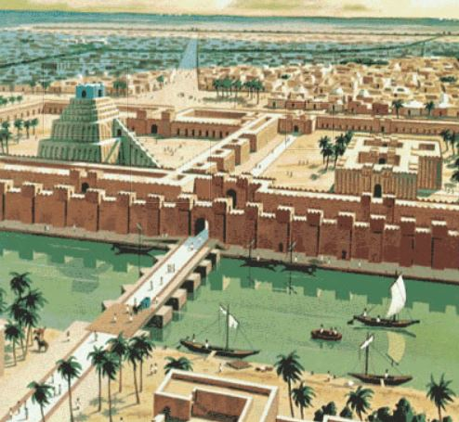
When Judgment is Redemption
Daniel 4:28-37
(see also: Ps. 7:11; Mal. 1:4; Rom. 1:22-25; 2 Pet. 3:3-4)
When Daniel told the king to repent:
a) the king laughed in his face.
b) the king asked why he should.
c) the king did not respond.
What is moralism?

The four divine elements revealed here:
I. The _________________ of the Most High.

II. The _____________ of the Most High.
Nebuchadnezzar seems distracted by two things:
#1

#2

Why does God extend his mercy to all men?

III. The _____________________ of the Most High.
Was this just a common ailment?

How does God judge the wicked in this world?

IV. The _________________ of the Most High.
How long did the ailment last?

Have I turned my eyes toward heaven?

New Covenant Presbyterian Church, PCA, Abingdon, MD (410) 569-0289

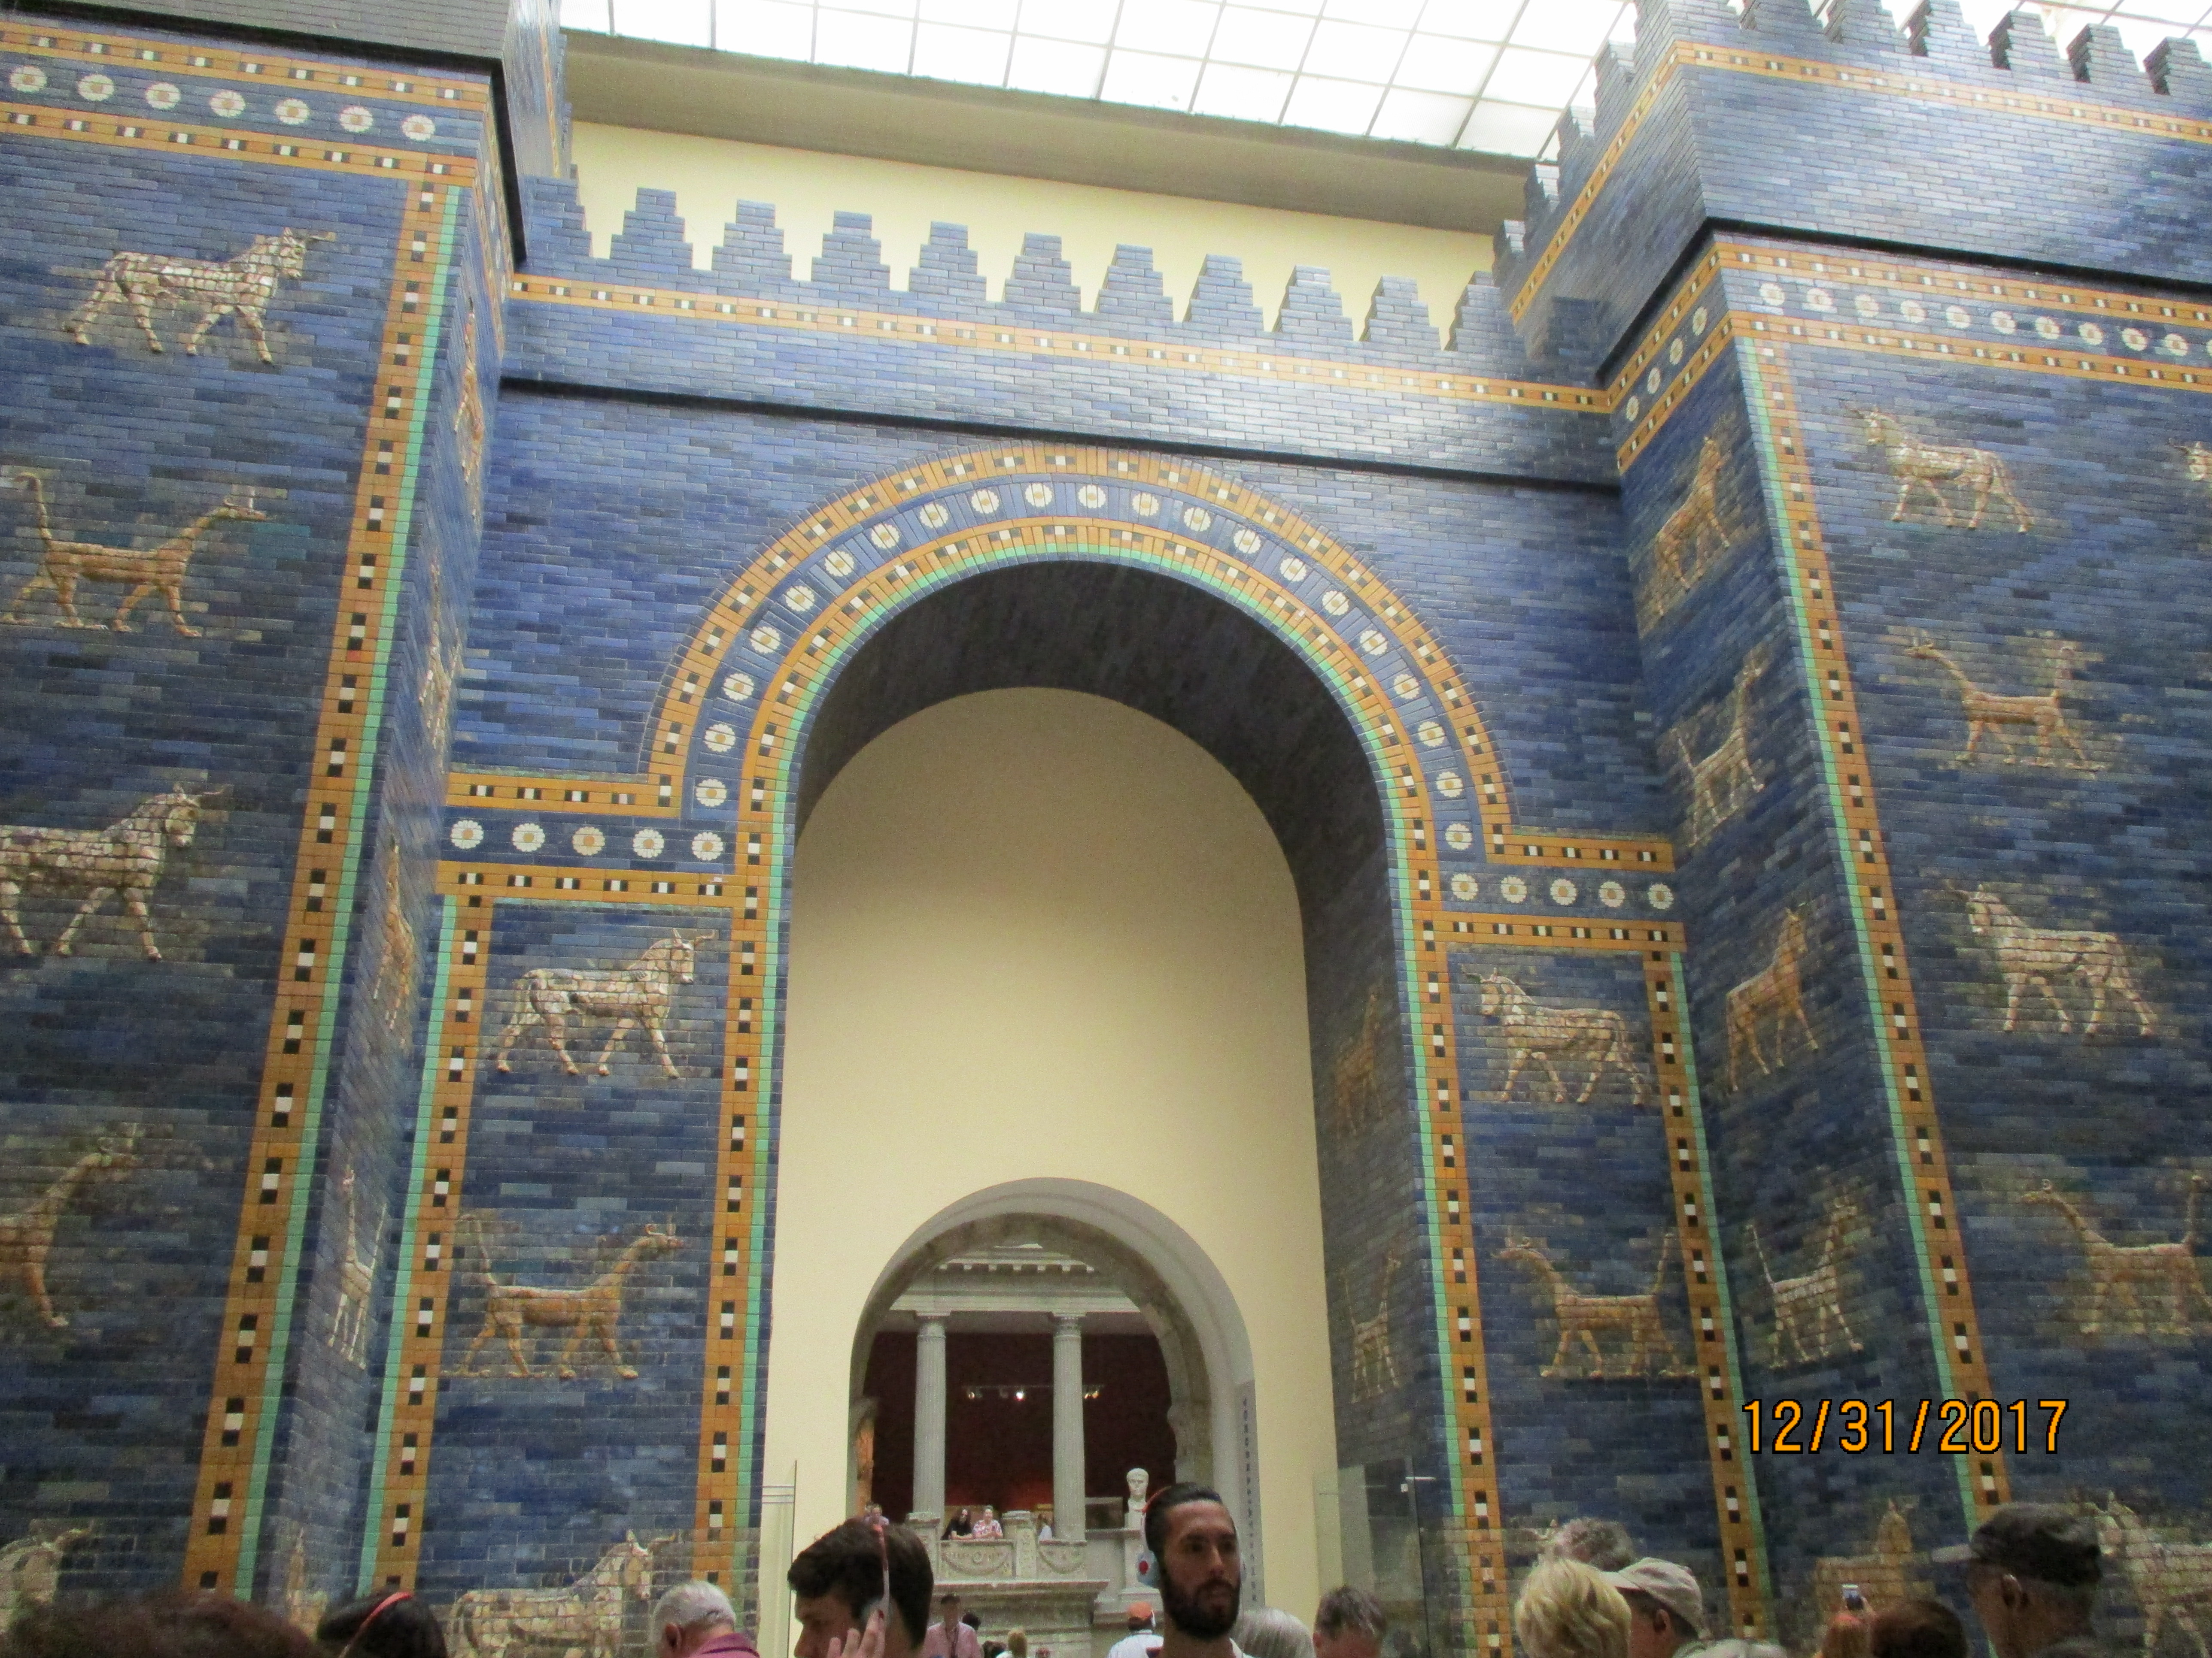

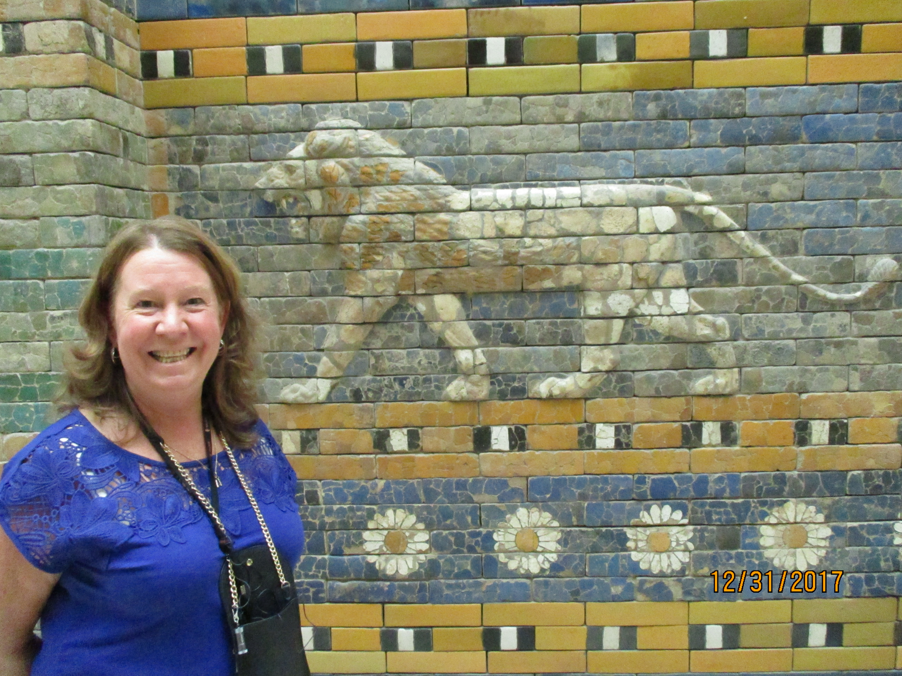

Studies in the Book of Daniel
A New King over Babylon!
Daniel 4:34-37
(see also: Job, Jer. 31:23; Jn. 3:3; WSC #33, 35)
What did you do in the 80s?
a) Never mind!
b) I was perfect in thought, word, and deed.
c) “I don’t recall.” (H. Clinton)
The mindset we have allowed ourselves to have:
#1

#2

Has Nebuchadnezzar truly become a believer?
I. The reality of transition.
What motivated him to turn to the Lord?

How did he act?

What was given him?

II. The transition of transition.
What is justification?

What is sanctification?

The example of Constantine.

III. Is there a presently happening transition?
What signs are there that my conversion is real?

What signs of my claim to faith might be questioned by others?

New Covenant Presbyterian Church, PCA, Abingdon, MD (410) 569-0289
Studies in the Book of Daniel
Tools of Interpretation
Daniel 5:1-4; 7:1-14
(see also: Num. 12:6; Dt. 29:29; Mt. 13:13; 24:36; )
By the time of Belshazzar, Daniel
a) is twenty-one years old.
b) is around 60 years old.
c) is dead and gone.
I. The kingly transition.
Nabopolassar

Nebuchadnezzar

Evil-Merodach

Nabonidus

Belshazzar

II. Daniel’s dream in the 1st year of Belshazzar (ch. 7)
How stable is the kingdom of Babylon now?

Have the people of Judah been waiting in vain?

III. Approaching vision/dream prophecy in Daniel
#1 - the _________________ of the dreams

#2 – the _________________ and _______________________
of the dreams

What is the most important distinction to learn and appreciate here?

New Covenant Presbyterian Church, PCA, Abingdon, MD (410) 569-0289
Studies in the Book of Daniel
The Son of Man and His Saints
Daniel 7:13-38
(see also: Dan. 2; 2 Cor. 13:5; Jms 4:8)
This vision is different because:
a) it appeared in living color.
b) it was not to an unbeliever but to God’s people.
c) Daniel didn’t like it.
I. Daniel’s dream parallels Nebuchadnezzar’s.
The lion represented ____________________.
(True/False): The Lord wanted to assure/comfort Daniel
that Nebuchadnezzar had truly been converted.
God, in his providence, allows the other three beasts to:

II. Daniel’s own pre-occupation with the fourth beast.
A. It will be the most _______________ yet (vs. 23-24)
The second beast stands for __________________.
The third beast stands for ____________________.
The fourth beast stands for ___________________.
B. Mankind emulates Rome.
Mankind was created by God to:

The Christian worldview is called
_______________ Philosophy
and it is based on the _________ ___________________.
But fallen man only seeks to:
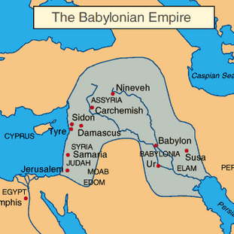

The “why” question creates
our ___________________.

The “how” question
helps us get there.

How shall we then live our lives?

New Covenant Presbyterian Church, PCA, Abingdon, MD (410) 569-0289
Studies in the Book of Daniel
The Coronation of Christ
Daniel 7:9-14
(see also: Gen. 3:15; Is. 53:4-6; Mt. 28:18; Rom. 3:9-12; Eph. 2:8-9)
Today, we are still in:
a) a state of denial.
b) Babylon.
c) Rome.
I. The context of the heavenly judgment.
(True/False): The exile of God’s people was to be permanent.

The entire purpose of Daniel as prophet
was to lead the Jews to r__________________,
to hope in God for their r_________________________,
for they were His r_____________________,
and would yet be r____________________________.
What foreshadowings have we seen so far?
#1
#2
#3
When your world is collapsing, what should you do?

II. What can the vision of heavenly judgment mean?
This judgment is pronounced upon the:

Is the gospel about “works righteousness”?
This judgment is laid upon the R______________________.
What is the worst thing mankind can ever do?

III. What happens after this?
The 4th beast will:
Christ will be:
Christ’s kingdom will:
In what does my hope lie?

New Covenant Presbyterian Church, PCA, Abingdon, MD (410) 569-0289
Studies in the Book of Daniel
A Call to Patience
Daniel 8:1-14
(see also: Lk. 1, 2; Rom. 2:6-7; 8:25; Gal. 5:22; Eph. 4:2; Col. 3:12)
This second vision given to Daniel is all about:
a) how dangerous certain animals can be.
b) sightseeing in other countries.
c) the role of patience in the life of the Christian.
(True/False): God gives us prophecies so we can spend all our
time studying them.
A brief survey the church’s influence on the 20th c.

I. Daniel has had another vision.
What has Daniel been doing since the 1st dream?

What does ‘keeping the matter in his heart’ mean?

Is it important that you are always happy in life?

II. Why was this vision in and of Suza?
What do we know of Suza historically?

What does Suza mean here?
#1:

#2:

What purpose does this vision serve for Daniel?
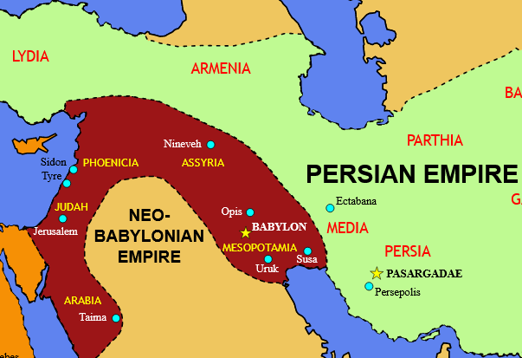

Do the Scriptures serve
that purpose in your life?

How must we live our lives
in faithful obedience to God?
Studies in the Book of Daniel
Not Understanding the Gospel
Daniel 8:15-27
(see also: Rom. 13; Mt. 5:13-16; Eph. 2:8-9)
If the vision of Dan. 8 taught us patience, its meaning teaches us:
a) to be afraid of wild animals.
b) steadfastness.
c) that the longest answer in a multiple choice
is always the right one.
The skeptics say Daniel’s writing cannot be authentic because:

I. The clear identity of the 2nd & 3rd kingdoms.
The second kingdom in the vision is ____________________.
The third kingdom in the vision is _____________________.
II. What does that mean for us today?
#1: Prophecy is not just for the end of time but for now.
Should I care about the govt./nation I live in now?

How has our own country been influenced by Christians?
#1: it is a ________________________.
#2: it is based on _________________.
#3: it functions on a system of _____________________.

#2: This world is not a _____________ playing field.
Example: the 1st Amendment to the Constitution
Congress shall make no law respecting an establishment of religion, or prohibiting the free exercise thereof;
This was written to avoid:

But it has been used to:

under the presumption that:

which means that mankind just:

Any form of govt. that excludes the Moral Law will:

If the nation must stand on the Moral Law of God
must that affect the way I live as a Christian?
New Covenant Presbyterian Church, PCA, Abingdon, MD (410) 569-0289
Studies in the Book of Daniel
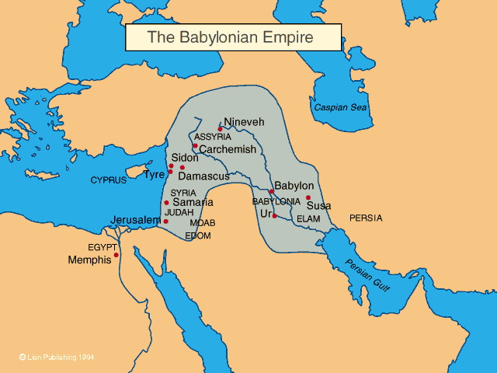

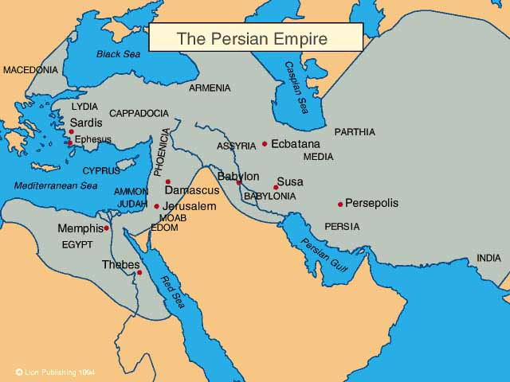

A King Who Knew Not Daniel
Daniel 5:1-12
(see also: 1 Sam. 5; holy to God: Col. 3:12; 1 Tim. 4:5; 2 Tim. 1:9; Heb. 3:1; God’s dwelling: 1 Cor. 3:17; 6:19; service to God is holy: Rom. 12:1; 1 Pet. 1:16; covt. children are holy: 1 Cor. 7:14; church together is holy: Eph. 2:21; 5:27)
The book of Daniel is regarded by skeptics as:
a) truthful in all its claims.
b) mostly truthful.
c) fiction unless proven to be true.
I. The background of this account.
How strong had Nebuchadnezzar made Babylon?

Did those strengths last until the days of Belshazzar?

II. The Temple Articles
First, they are:

Second, they are:

III. Now, it is the Christians who are those articles.
First, we are:

Second, we are:

How valuable to God am I?

New Covenant Presbyterian Church, PCA, Abingdon, MD (410) 569-0289
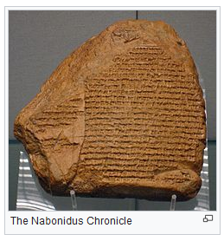

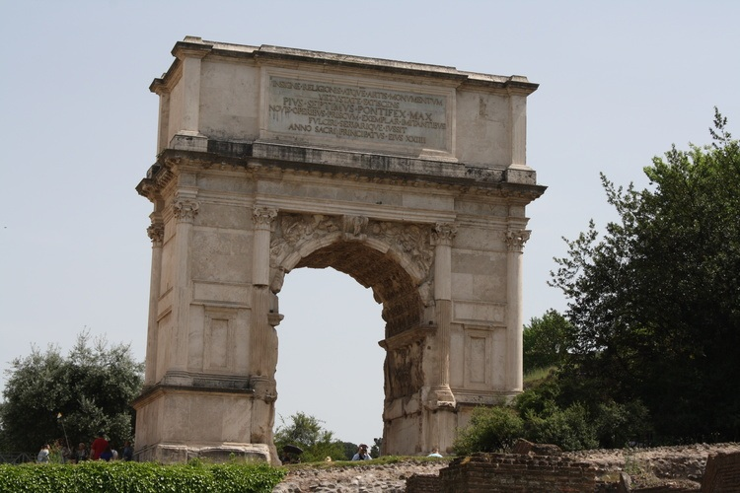

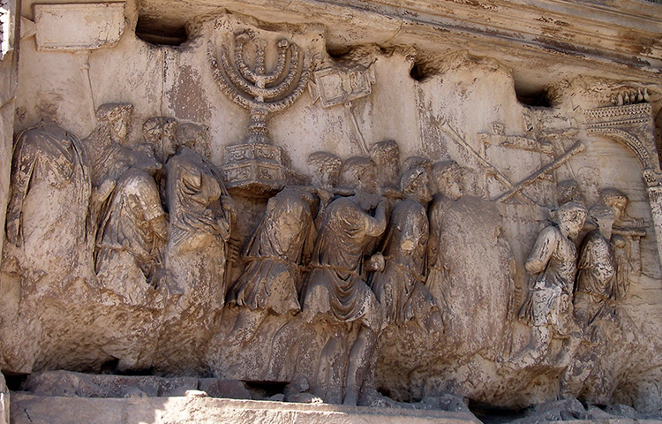

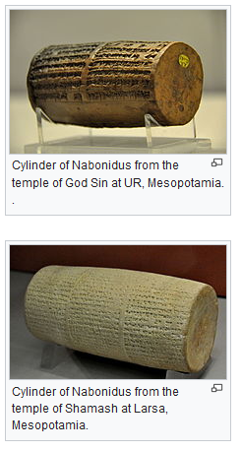

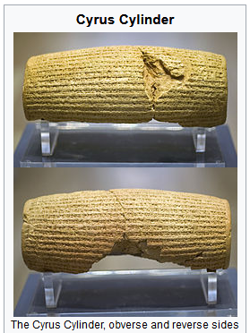

Studies in the Book of Daniel
A King Who Knew Not Daniel
Daniel 5:10-23
(see also: 1 Kgs. 12; Ps. 146:3; Mt. 16:18; 21:23-27; Jn. 8:32; Acts 4:12; Rom. 3:10)
The mother of Elizabeth II was:
a) Elizabeth Angela Marguerite Bowes-Lyon
b) Christine Blasey-Ford
c) Blanche
The party
who all was there?
when did the fun stop?
The handwriting
Could the counselors read the message?
Who wasn’t among them?
Why did the queen come forward?
Lessons
#1:
a)

My personal values should be in line with:

b)

Is corruption in government inevitable?

What is the one thing that can curb corruption?

How does a nation regain its conscience?

#2:

Is the truth of the Bible ever “old-fashioned” or
“outdated”?
What will bring biblical truth of the gospel back into
politics?

New Covenant Presbyterian Church, PCA, Abingdon, MD (410) 569-0289
Studies in the Book of Daniel
The Fall of Babylon
Daniel 5:24-31
(see also: Dan. 3:16-18; Jonah; Mt. 6:33; 21:43-44; Eph. 2:11-22; Phil. 2:7-8; Heb. 9:27)
The gospel breaks down the barrier between:
a) Romans and Barbarians.
b) Jews and Greeks.
c) Christians and Muslims.
What is the difference between Jonah and Daniel?

Daniel speaks to King Belshazzar.
I. He teaches Belshazzar about Nebuchadnezzar
Why did the Lord humble Nebuchadnezzar?

Why does hardship come into our lives today?

What change did Nebuchadnezzar experience?

II. Daniel declares Belshazzar’s own need for rebirth.
Was Belshazzar worse than Nebuchadnezzar had been?

How is the gospel ever and only received?

III. Daniel interprets the writing on the wall.

The gospel is both ______________________
and _______________________,
in ____________ life as well as in ___________________.

So, which kingdom am I seeking?

New Covenant Presbyterian Church, PCA, Abingdon, MD (410) 569-0289
Studies in the Book of Daniel
The Living Scriptures
Daniel 9:1-2
(see also: Jer. 25; Dan. 5:30)
Babylon has fallen. Therefore,
a) Daniel did not need to try anymore.
b) Daniel needed to “get out while the getting was good!”
c) Daniel needed to trust God all the more.
Circumstances we need to know about:
1)

2)

a) son of Ahasuerus
b) by descent, a Mede
c) to “have received” or “made king”
We have seen the character of Daniel in public:
but what was the man in private?
I. Daniel’s attention and devotion to the Word of God.
How much of the Old Testament did Daniel have?

Who was Jeremiah?

Applications for ourselves:
#1

#2
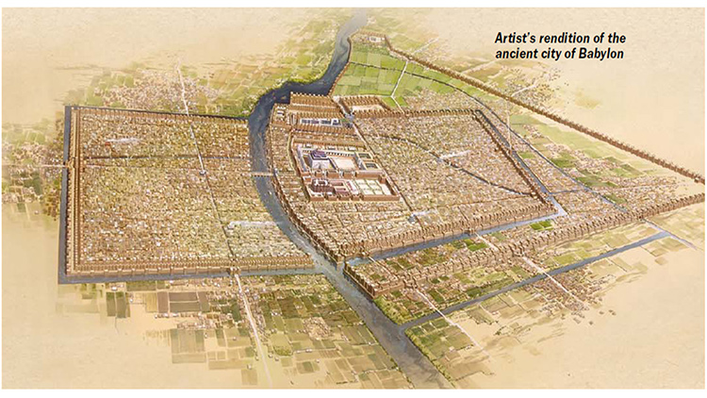

#3

Have I given up
on the Word of God?

New Covenant Presbyterian Church, PCA, Abingdon, MD (410) 569-0289
Studies in the Book of Daniel
Hope in Judgment
Daniel 9:1-2; Jeremiah 24:1-7; 25:8-14
(see also: 2 Chron. 36; Jer. 36; Jude 3; Rev. 2:7)
Daniel brings to Scripture his questions
a) after he has looked everywhere else for answers.
b) because he really doubts God speaks in the Bible.
c) because only there will he find his answers.
Three questions come to mind here:
I. Why did it take so long for Daniel to read Jeremiah?
Why wasn’t Jeremiah popular as a prophet?

Where did Jeremiah go toward the end of his life?

II. What did Jeremiah teach Daniel?
Which basket of figs were the exiles?

Was learning the exile would end in 70 years good news?

Where do we learn how to trust God?

III. Why seventy years?
Why were Chronicles written?

The Israelites had forsaken 70 years’ worth of
_____________________.

What day of the week do Christians observe?
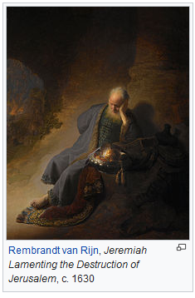

It forms a clear identity
of each of our _________________________ witness
and testimony to ourselves
as well of our ________________________ witness
and testimony to the world.

What is my visible witness to other believers and to the world?

New Covenant Presbyterian Church, PCA, Abingdon, MD (410) 569-0289
Studies in the Book of Daniel
“We Repent!”
Daniel 9:3-15
(see also: 2 Chron. 36; Jer. 24-25; Is. 58; 1 Jn. 2:15)
Jeremiah had said the exiles
a) were just a bunch of worthless vermin.
b) going to be forgotten.
c) were actually the remnant.
Key things in Daniel’s life:
1) his attention & devotion to the ____________ ___ ______.

2) his commitment to ____________________.

I. Daniel prays to the Lord God known to his people.
Daniel’s prayer is ________________________.
#1

#2

Daniel repeats how God has revealed himself.
He is _________________ (vs. 7).
To him belong _____________ and __________________ (vs. 9).
He is also the God of ________________ (vs. 13).
He is ___________________ to his people.
II. Daniel knows the heart of man.
He knows their state of ___________.
He knows they are ____________________.
He knows that ____________ will continue to be in their hearts.

What is the spirit of my heart before God?

New Covenant Presbyterian Church, PCA, Abingdon, MD (410) 569-0289
Studies in the Book of Daniel
A Desolate Sanctuary
Daniel 9:16-19
(see also: Num. 12:7; Ezek. 10; Mt. 23:38; Rom. 1:21, 24-25)
The word that best describes the prayer of Daniel here is:
a) long.
b) eloquent.
c) worshipful.
Daniel’s spiritual strength comes from:
1)

2)

In his prayer, Daniel asks for
I. the name of the Lord to be ____________________.

II. the anger & wrath of God
be ______________ _______________.

What does “desolate” mean?

How does Christianity “progress” with the times?

III. the ultimate ___________________ of God.

What am I praying for?

New Covenant Presbyterian Church, PCA, Abingdon, MD (410) 569-0289
Studies in the Book of Daniel
The Man Gabriel
Daniel 9:20-23a
(see also: Dan. 8:16; Lk. 1:19, 26; Heb. 1-2; Rev. 1:3)
The subject of angels in the Bible
a) is made up in order to keep children hopeful.
b) is the same as we see in movies & TV.
c) is to be taken seriously & uniquely.
I. The witness of all of Scripture
is that angels are ____________.
Where do you really get your theology?

Because Daniel mentions angels, do we dismiss him?

II. That angels exist is tied to _____________ they exist.
What does “angel” mean?

They rank ________________ Jesus.

They bring the elect into __________________ -

first we are made _______________ the angels,

but then, they are _________________ of God’s people.
III. The angel that appears to Daniel.
while I was speaking in prayer, ...

the man ... came to me in swift flight ...

What about the name Gabriel?

IV. Approaching the rest of chapter 9.
Where should we begin?

What may we conclude was Gabriel’s primary task?

How might that affect his prophecy to Daniel?

Do I look into heavenly things that even angels are not allowed?

New Covenant Presbyterian Church, PCA, Abingdon, MD (410) 569-0289
Studies in the Book of Daniel
Seventy Weeks
Daniel 9:24-27
(see also: 2 Chron. 36:20-21; Jer. 24-25; Eph. 5:22-33; Rev. 21:9)
If we have the source of truth but deny it:
a) we have nothing left.
b) we have to come up with some other truth.
c) we deny that we need truth anyway.
I. Remembering the context
Jer. 24_25: the exiles are:
Daniel’s prayer asks for:
II. Gabriel answers with another 70.
weeks?
translation?
Vs. 25: And thou shalt know and understand, from the going forth of a word to restore and to build Jerusalem unto an anointed one, a prince (is) seven sevens and sixty two sevens; it shall be built again street and moat and in affliction of the times. (E.J. Young, The Prophecy of Daniel)
What Dispensationalism teaches about this.

Why that is wrong:
#1

#2

#3

Three more things to keep in mind:
#1

#2

#3

The timeline does not point to judgment but to:

The final “70” is that of:

“The issue ultimately involved is whether there is a source of truth higher than, and independent of, man; and the answer to the question is decisive for one’s view of the nature and destiny of man.” (R. Weaver, Ideas Have Consequences)
New Covenant Presbyterian Church, PCA, Abingdon, MD (410) 569-0289
Studies in the Book of Daniel
Making Righteousness a Crime
Daniel 6:1-10
(see also: Ps. 92:12-15; Dan. 2:48; 5:12, 14; 29; 9:1; Heb. 11:33)
Daniel has now served
a) Nebuchadnezzar, James IV, and Ivan the Terrible.
b) Julius Caesar, Mussolini, and Barak Obama.
c) Nebuchadnezzar, Belshazzar, and Darius.
The background of Persia’s political system.

Daniel was continually singled out for his

_________________________ ____________________.

Have politicians changed since Daniel’s day?

What does it mean to “be like
Daniel”?

What is the role of law in government?
to _________________ the sinful heart.

to stand _____________ everyone.

Are you glad you don’t have to be a Daniel?

New Covenant Presbyterian Church, PCA, Abingdon, MD (410) 569-0289
Studies in the Book of Daniel
No Room for Conscience
Daniel 6:10-18
(see also: Ex. 20:3; Mt. 22:36-37; Eph. 6:13)
Daniel went to his room & prayed
a) because the law of Moses required it of him.
b) because he wanted to show off to others.
c) because he loved his God & Deliverer with all his heart.
Daniel is in the spotlight!
I. His character is in the spotlight.
Daniel was a man
of ____________________, _______ ______________,
and who was willing to ___________________ his God.

Was Daniel so good that he didn’t need a Savior?

II. His God is in the spotlight.
It was not Daniel’s _____________________
that made history,

rather it was Daniel’s ____________.

III. His choice is in the spotlight.
Daniel lived a life of obedience and trust
because he _____________ his Lord.

Daniel’s great test came when:

Was it necessary to pray three times a day?

Couldn’t he have refrained from praying for 30 days?

Is it always necessary to be a martyr?

Conclusion:
“The way of ________ lies here.” (Pilgrim’s Progress)
Do we just hope that our own sacrifices for our faith
actually accomplish something?

New Covenant Presbyterian Church, PCA, Abingdon, MD (410) 569-0289
Studies in the Book of Daniel
“May God Deliver You”
Daniel 6:16-28
(see also: Ps. 92; Is. 11:6-9; 66:24; Lk. 24:13-35; Heb. 11:33-34, 39-40; Rev. 4:11; 5:13; 20:10, 14)
The lions’ den was
a) a cave outside the area of the city.
b) an empty cistern dug into ground.
c) a complex like modern day zoos.
Why deliver Daniel?
How did a den of lions work as a form of execution?

What did Daniel likely do during the night?
1)

2)

The ultimate and final justice of God
is a vital part of the __________________.

What does the Old Testament teach us?

How does the end of this episode glorify God?

Darius –

Daniel’s deliverance –

the punishment of Daniel’s accusers –

New Covenant Presbyterian Church, PCA, Abingdon, MD (410) 569-0289
Studies in the Book of Daniel
The Return Begins
Daniel 10:1-4
(see also: Is. 60:1-3, 11; Ezra 1:1-4)
The regents Daniel has interacted with were:
a) Larry, Curly, Moe, and Shemp
b) Henry VIII, Mary, Elizabeth I & Victoria
c) Nebuchadnezzar, Belshazzar, Darius, & Cyrus
I. The third year of the reign of Cyrus
(True/False) Contrary to God’s design, Cyrus will keep
the Judahites in Babylon.
Assyria -

Babylonia –
1)

2)

3)

4)

Persia -
What archeology can tell us:

What the Bible tells us:

II. Daniel’s mourning
What’s this about?

What must have been done all along?

What must we do?

New Covenant Presbyrian Church, PCA, Abingdon, MD (410) 569-0289
Studies in the Book of Daniel
The Man
Daniel 10:5-11:1
(see also: Is. 55; Ezek. 1:26ff; Mt. 17:2; 28:3; Acts 9:3; Rom. 8;
Eph. 6; Heb. 11:8; Rev. 1:12-16)
When God says his thoughts are not our thoughts, it means:
a) we must be ready to change our thoughts.
b) God is so above us we can’t fathom his thoughts.
c) God’s thoughts are just better than our thoughts.
I. A man clothed in linen (vs. 5)
Clues as to who this might be:
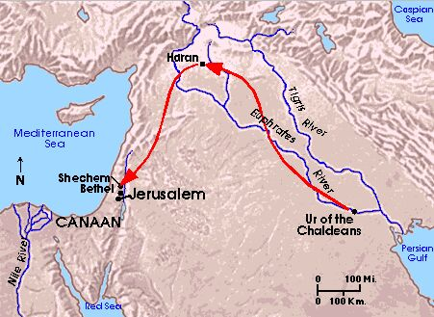

What is on this man’s mind?

II. The man’s message (vs. 14)
What was involved in this return?
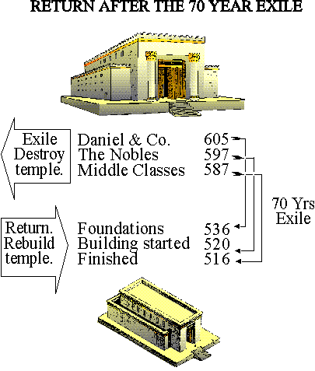

Why were they reluctant?
1)

2)

III. Michael, the prince
(vs. 13, 21)
Who might this be?

Is it really necessary to believe angels exist?

Where does the Christian’s confidence come from?

New Covenant Presbyterian Church, PCA, Abingdon, MD (410) 569-0289
Studies in the Book of Daniel
Understanding Spiritual Warfare
Daniel 11:2-4
(see also: 1 Kgs. 22; Zech. 3; Mt. 12:43-45; Lk. 8:2, 26-33; Rom. 8:28-30; Eph. 6:12)
The last three chapters of Daniel
a) have nothing to do with us today.
b) speak of that which is still yet to come.
c) reveal the spiritual warfare in the world.
I. Is spiritual warfare really true?
Not only are the messengers of God for real,
so also are the _____________ angels.
Old Testament references:
Gen. 3:

Job:

New Testament references:
Demon-possession:

1 Pet. 5:8-10:

Attacks on Christ:

Attacks on men/nations:

II. The ordained will of God for the future
Persia:
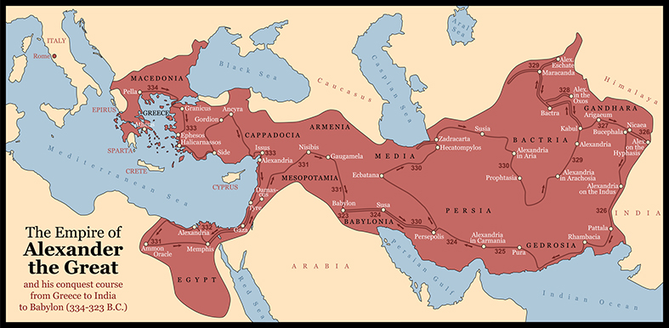

Greece:

III. Three Lessons
Spiritual warfare:

God ordains:

God’s ways:

Must I believe in this God?
New Covenant Presbyterian Church, PCA, Abingdon, MD (410) 569-0289
Studies in the Book of Daniel
A Desolate House
Daniel 11:5-35; Mt. 23:37-25:46
(see also: Jn. 1:14; Acts 9:1-2; 20:17-35; 2 Cor. 6:17)
“Desolate” means:
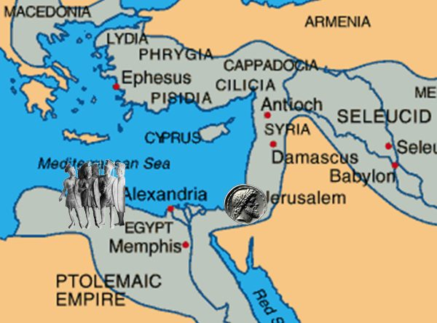
a) popular, fun, exciting
b) quiet, substantive, effectual
c) abandoned, deserted, empty
I. The larger picture of Daniel 11
Vs.s 1-4

“the 400 silent years”
Vs.s 5-35 less time
and more detail tell us:
Vs. 31
This is a __________________ verse
probably referring to Antiochus Epiphanes
(Epiphanes means _______ _____________,
who:

II. Jesus’ prophetic words of warning in Mt. 24:15.
A. What will happen to Herod’s Temple?
What will the disciples see?
The _____________________ of _______________________.
B. How this relates to Daniel.
1. “Let the reader understand”

May a Christian flee persecution?
2. “when you see the abomination ... standing in the holy place.”
Will this be a one-time event?
What does history teach us?

3. “the abomination of desolation”
Who left the house desolate?
What is the new house of God today?

Will God ever leave this new house?
Do I belong to this new house, his church?

New Covenant Presbyterian Church, PCA, Abingdon, MD (410) 569-0289
Studies in the Book of Daniel
Michael, the Warrior
Daniel 11:36-12:4
(see also: Num. 12:6-8; Dan. 2, 7-8; Mt. 13:10-17; 2 Thess. 2; 2 Tim. 3:1; Heb. 1;2; 1 Jn. 2:12; Jude 9; Rev. 12:7-17)
The end of this prophecy in Daniel
a) has nothing to do with Jesus’ words in Mt. 24-25.
b) are almost precisely similar to Jesus’ words in Mt. 24-25.
c) is cancelled by Jesus’ words in Mt. 24-25.
What do we mean by “a prophet’s perspective”?

I. An apparent “turning point” between vs. 35-36.
What happens at this “turning point”?

Why isn’t more said about it?

Who is spoken of more here?

Is this one person or several?

What are the signs:
vs. 36 –

vs. 36-37 –

vs. 39 –

II. The Archangel Michael
What is his task?

When does he do this?

III. Finally, the last struggle
How is the final battle won?

Then, vs. 2 –

And, vs. 3 –

New Covenant Presbyterian Church, PCA, Abingdon, MD (410) 569-0289
Studies in the Book of Daniel
“Go Your Way”
Daniel 12:4-13
(see also: Mt. 24-25; 2 Tim. 3:16-17; 1 Pet. 1:12; 2 Pet. 3:9-13; 1 Jn. 4:4)
The end of the book of Daniel is like the end of:
a) Gone with the Wind
b) the book of Acts
c) a long freight train.
(True/False): Daniel returned with the 3rd group of Judahites.
I. What does all this mean (vs. 4)?
The pursuit of knowledge alone is:

#1) Knowledge is ____________________.

#2) Knowledge is ____________________.

#3) Knowledge is ____________________.

The gift of wisdom comes from:

II. How long will it be (vs. 6)?
“time, times, and half a time”; 1,290 & 1,335 days
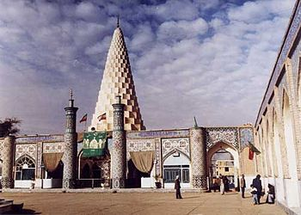
The Tomb Monument of Daniel, Suza, Iran

what can we know?

III. What do I do now?
A. shut up & seal
the book (vs. 4)

B. go your way (vs. 13)

Grant, Almighty God, since thou proposest to us no other end than that of constant warfare during our whole life, and subjectest us to many cares until we arrive at the goal of this temporary race-course: Grant, I pray thee, that we may never grow fatigued. May we ever be armed and equipped for battle, and whatever the trials by which thou does prove us, may we never be found deficient. May we always aspire towards heaven with upright souls, and strive with all our endeavors to attain that blessed rest which is laid up for us in heaven, in Jesus Christ our Lord. Amen. (Prayer of John Calvin)

